2020 -Summary of Winners

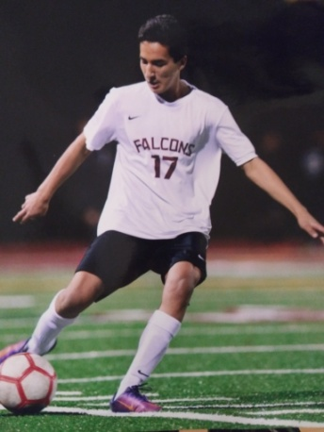

AJ (Abel) Castellanos
Join me in congratulating the next Gregg's Goals 2020 scholarship winner: AJ (Abel) Castellanos from Torrey Pines High School. Unfortunately, AJ's soccer career was hampered by injury. In his sophomore year in high school, he suffered a severe concussion while playing that put him out of sports for the entire year. Once he was cleared, he began to work to get back into shape - spending countless hours training. As a result, he returned to his high school team by his senior year and they won CIF in their division. While he has not committed to a university yet, he has a high GPA out of high school and plans to attend a four year college and pursue a degree in kinesiology with the goal of becoming a physical therapist.
AJ wrote that soccer taught him great life lessons about community, perseverance, work ethic, team work and "even friendship". He is described by his coaches as being a team leader, respectful, hard working kid with maturity and self control. IT was also noted that he is a role model for younger players and gave of his time to teach other kids how to play. We are proud to be able to present AJ with this scholarship, as he continues to pursue his goals!

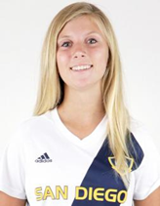
Savannah Weebe
Please join me in congratulating, Savannah Weebe, our final featured scholarship winner and the only female this year!
Savannah has excelled in all areas of life - she has played soccer for 13 years, learning confidence, communication, team work and leadership. Her coaches praised her unselfish play, support of the team, hard work and a "a kindhearted and compassionate young woman". She has demonstrated this by her multiple activities, and being elected as both captain of her varsity soccer team and club soccer team (multiple years). She has been involved in the Fellowship of Christian Athletes, as well as taken an active role in ASB at her school. Through her soccer club, she taught young special needs kids how to play soccer in a program called Champions League. In addition, she has been an assistant coach to young girls in recreational soccer.
Savannah has always prioritized academics and kept a high GPA, as well as awards from the California Scholarship Federation and the National Honor Society. She is planning to attend Sonoma State and major in Busineds Administration.
Savannah truly exemplifies the traits sought in a GG scholarship winner!

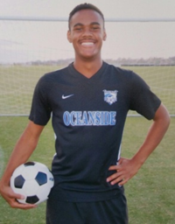
Justin Ricketts
Our next scholarship recipient is Justin Ricketts, from Mission Vista H.S. in Oceanside. Justin played on the varsity soccer team at MV since his freshman year, and is described as "hard working, dedicated, talented" and a player who loves the game and loves to compete. He is also described as consistent and reliable. . .and one of the best fundraisers the program has had. He received nearly all "excellents" on the rating forms from those coaches and counselors. He maintained a high GPA, while taking AP courses. His plans are to attend CSU Chico and major in Biological Sciences, while playing soccer there. It is a pleasure to help Justin meet his goals!

Michelangelo Harte
Michelangelo Harte hails from Mission Hills High School. Michelangelo is an excellent student, who has a h.s. 4.05 cumulative GPA and has taken 5 AP courses. He credits his success to diligent study and discipline, which he carries over to other parts of his life. For example, he has performed more than 80+ hours of community service, including working as a church leader. He has been captain of his club team 2 out of 4 years, despite having to work through serious injuries, including ligament tears and stress fractures. A third injury put him out of soccer for months. While he missed playing soccer, he learned to draw, lifted weights and got closer to God by attending multiple Masses per week. The injury impacted his view of his future, and he has decided to study Kinesiology with an emphasis on physical therapy, while playing soccer at the University of La Verne. Best of luck to this young man in meeting his goals!

Five continuing recipients:
Summer Slough -last year at SDSU
Daniel Zin - finishing up at Carlton College, MN
Jacob Cotton - sophomore - HSU
Charlize Wolf - St. Katherines, San Marcos
Tommy Yarbrough - Whittier College

